1. **Question: How to store research data on-chain?**

I was wondering if we could store only the hash of the research data in a NFT.

For example, once Dr. X submits his research papers on to IPFS then a hash of the file is generated and that hash is mapped to the NFT.

1. **Question: Granular Breakdown of Project Roadmap**

## **Week 1–2: Research Proposal Submission**

* Design and deploy a smart contract to allow researchers to:
  + Submit research proposals with metadata (title, abstract, funding goal).
  + Store proposal data on-chain using compressed NFTs for cost efficiency.(I am not sure if this is the correct way of storing proposal data)
* Integrate Arweave or IPFS to store large files (e.g., PDFs of research proposals).

## **Week 3: Simple Funding Mechanism**

* Implement a straightforward funding system:
  + Contributors can directly fund research proposals.
  + Track each contributor’s funding amount and their proportional ownership in the project.
* Write logic to lock funds in an escrow account until milestones are completed.

## **Week 4: Milestone-Based Payments**

* Add milestone tracking for funded projects:
  + Researchers define milestones during proposal submission.
  + Funds are locked in escrow and released incrementally upon milestone completion.
* Implement manual milestone verification (e.g., admin approval) for MVP.(Implementing a DAO based or group of researches who would vote for the authenticity of the research would be better instead of just one person validating the research papers)  
    
    
  **Here’s a flow diagram of the business model of the project**

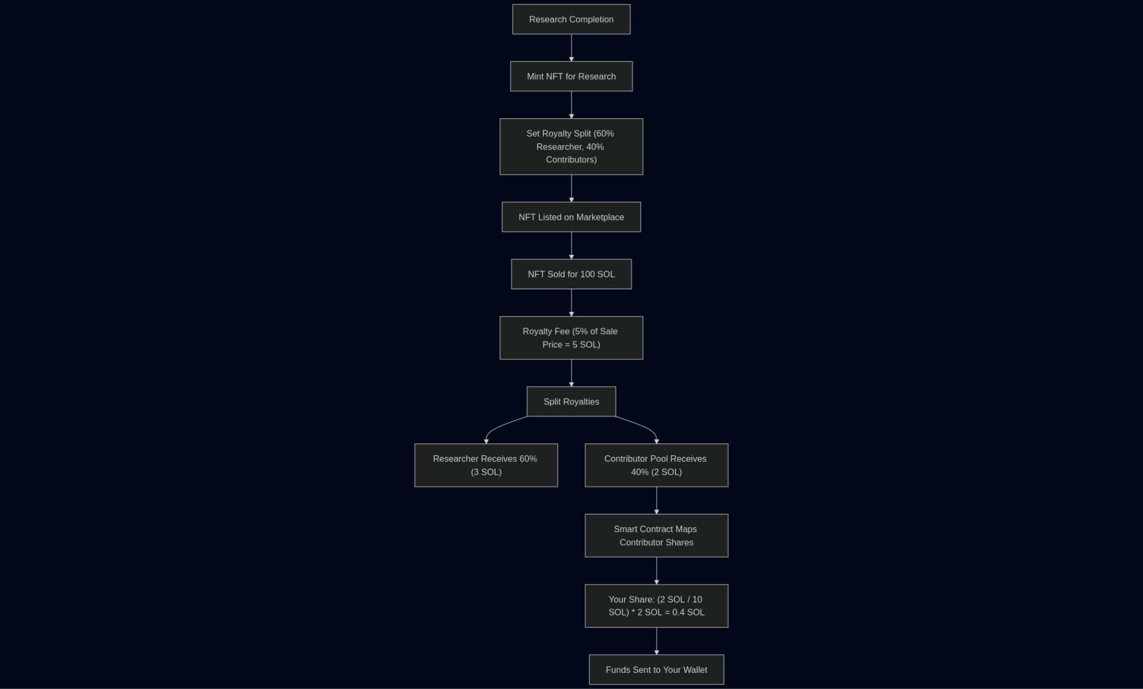

Question:**Are there any preventative measures implemented for fake/unfulfilled milestones? What is the criteria for a "milestone"?**

Answer:

**Milestone Verification Process**

1. **Validation Mechanism**:  
   * Milestones are manually verified by other researchers on the chain. To confirm validity, at least two independent researchers must **replicate the results**.
   * After replication, validators vote on whether the findings are correct. Validators are **incentivized** (e.g., through token rewards or profit-sharing) to ensure honest participation.
2. **Milestone Definition**:  
   * A milestone is a **researcher-defined checkpoint** tied to specific, measurable outcomes (e.g., experimental results, prototype completion, or peer-reviewed publication).
   * These checkpoints must align with the project’s broader goals, such as solving a sub-problem or achieving a technical breakthrough.

Question:  
**What happens with the funding if the project is incomplete or dropped?**  
  
Answer:   
